Sex, Drugs, and Parenting: How Sex and Present Parents Impact the Drug Habits of High Schoolers

Eastern Connecticut State University

MAT 315

Date xxxxx

(Authors names have been removed)

**Abstract:**

In this technical report, there will be an exploration of the possible relationship between the variables of sex, marijuana usage, and parental presence. The data being used in this report is from the Monitoring the Future Project, where high schoolers across the country are randomly selected from cluster sampling. There are around 50,000 students surveyed who participate in this study, ensuring the quality, reliability, and the validity of the study. First to be examined is high schoolers’ smoking frequency. Then the data set will be separated by sex in order to analyze if there is a relationship between the two variables. Following that, will be elaborations on the possible associations with those who smoke marijuana, parental presence and marijuana usage, and marijuana usage over time. In analyzing parental guidance that the high schoolers are subject to, it will be inspected whether living with mother only, father only, neither parents, or both parents will affect one’s marijuana habits when separated by sex. Moreover, marijuana usage will be scrutinized with the variable of time in order to see any changes and possible trends that any arise over the course of a decade. Statistical and analytical techniques such as the chi-square test, bar plots, tables, and a time plot will be included in order to truly comprehend and understand the data.

Table of Contents

**Introduction**………………………………………………………………………...……….**4**

**Methodology**…………………………………………………………………………………**5**

**Analysis**………………………………………………………………………………………**7**

**Marijuana Usage**…………………………………………………………………….**7**

**Sex and Marijuana Usage**…………………………………….…………………….**8**

**Parental Presence and Marijuana Usage**………………….….……...…………….**9**

**Marijuana Usage Over Time**……………………………………………………….**12**

**Conclusion**……………………………………………………………………...……………**15**

**Appendices**………………………………………………………………………...…………**17**

**Appendix A**………………………………………………………………………….**17**

**Appendix B**………………………………………………………………………….**18**

**References**……………………………………………………………………….………….**21**

**Introduction:**

**[Comment: First paragraph after heading is not indented! You will find that this convention is also used in your textbook.]**

In today’s society, marijuana usage has become more prevalent. This report analyzes associations between sex and marijuana usage and whether or types of parental presence in adolescents’ households influenced their drug use over the period of 2006-2016. Learning about and understanding high schoolers: specifically, the relationships between their sex, parents, and how it all impacts the decisions they make (is imperative when considering the future of our society). Current high schoolers are the future and will soon oversee what direction this country and society will go. If it is possible to understand them and analyze data about them to find out any issues that are arising in order to be proactive about solutions. For example, understanding drug habits among youth is necessary when making and amending federal and local policies, such as the possible legalization of marijuana. In addition, patterns of drug use in youth could reveal that more efforts need to be put towards rehabilitation centers and changing societal values to see drug addiction as an illness and not as a crime. Moreover, looking at the association between drug use and parenting could reveal the importance of improving parental relationships with children.

The first question addressed, is how many adolescents smoke or not. Upon further questioning, is whether one’s sex has a relationship with drug use; the hypothesis being that males are more likely to partake in marijuana usage than females. Crane, Langenecker, and Mermelstein, in their study on gender and smoking, “suggest[ed] that males may be particularly vulnerable to the negative consequences of marijuana use, [and] it may be that marijuana is a coping mechanism for males to deal with symptoms of depression “(2015). Additionally, another factor to consider is parental presence in their homes. Our question is whether there is an association between a father and/or mother being present in one’s household and one’s marijuana habits. It is hypothesized that males who live with only their mothers and females who live only with their fathers are less likely to do drugs than males who live with their fathers and females who live with their mothers. Moreover, time is another factor to consider. This report will include data sets from the years 2006 through 2016; there are cultural influences of the time to acknowledge and possible trends, such as if the marijuana usage has increased or decreased over the last ten years. The hypothesis is that over time more high schoolers are getting involved in the use of marijuana.

**Methodology:**

The data being used in the analyses is gathered from The Monitoring the Future (MTF) Project, which was started in 1975. The researchers of this project collect data from a survey sent out to about 50,000 adolescents from around 420 public and private schools across the United States in order to study the change of attitudes, beliefs, and behavior of 8th, 10th, and 12th graders. This project is aware of the importance of understanding youth; results of this study are used by policymakers when making new or updating policies on topics such as health and planning/setting national health goals. The MTF project uses stratified cluster sampling in order to send out their survey. This process includes the selection of various geographic locations, the selection of schools within that area, and then the selection of classes within that school.

Although the MTF project does everything it can, there are flaws in every study. For example, due to the time that this survey is given out they are unable to collect data from all target populations. High school students that drop out right before graduation are not able to take this survey, which not only leaves out a small yet important population but inadvertently creates a bias. However, due to the small percentage of this group (about 9-20% of each age cohort) the researchers do not expect this to create a bias that would prove this study invalid. Also, race is condensed into three categories in order to promote confidentiality and anonymity. Furthermore, for the specific purposes of this technical report, when examining parental presence in order to determine a relationship with marijuana usage of high schoolers, it will not be known if students have two fathers or two mothers present in their household. This is most likely intentionally done in order to ensure the anonymity of high schoolers who have same sex parents.  Moreover, this project asks sensitive questions about illegal substance use, so for ethical reasons and to ensure students to answer truthfully confidentiality is maintained for all participants of the survey. Only some of the researchers who have two forms with a special code would be able to match answers to a specific student. Some question the validity of the answers to these questions due to its illicit content. However, the results over time throughout several different geographic locations, would show that the students who answer these questions answer them truthfully.

From the data collected by the MTF project, analyses will be conducted in order to interpret and understand the information gathered. Techniques such as using chi-square tests will be used in order to evaluate the association, if any, between variable sets that are defined in the questions presented. Moreover, there will be displays that show appropriate conditional distributions in order to comprehend the data sets. Additionally, a time series will be conducted in order to view the trends over time of the data sets. In addition, two-way tables, time plots, bar graphs, and tables using percentages of the information will be made and used in this analyzation. They will provide visual representations of the relationships between the variables.

**Analysis:**

***Marijuana Usage:*** [Comment: I would probably eliminate this heading and just dive into a discussion of the response variable. However, I would not use the term response variable in the report.]

To begin, the prevalence of marijuana usage of both males and females will be explored on its own. The data being used is from marijuana habits of high schoolers of the year 2016. When doing this it becomes apparent that 61.68% of teenagers are not using marijuana. There are two categories that describe moderate marijuana usage that combined 17.6% of teenagers partake in; this is less than the total percent of those who use marijuana more than 20 times, which could be considered marijuana abuse.

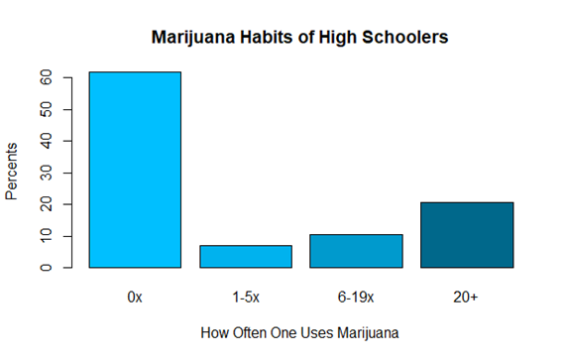

**Figure 1.** Marijuana Habits of High Schoolers of Both Sexes Using Percentages. Table of data in Appendix B.

Figure 1 illustrates high schooler’s marijuana habits using percentages. More than half of the students do not smoke marijuana; although the other 38% of the population of high schoolers is a substantial amount and is worth analyzing the possible relationships within its data set.

Next there will be an exploration on other variables to explore the possible relationship marijuana usage has with topics such as sex, or parental presence. The null hypothesis (Ho) states there is not relationship between sex or parental presence and marijuana usage and the alternative hypothesis (Ha) opposes this and believes there is an association between the variables.

[Comment: The previous paragraph serves as a transition to the subsection that follows. Such transitions help the reader.]

***Relationship Between Sex and Marijuana Usage:***

Addressing the first research question, we look at the association between marijuana usage and sex; more specifically, whether males are more likely to smoke than females. In the original data set there were six possible responses to the question on marijuana usage. (See appendix for question and possible responses.) For this analysis, we have combined responses into four categories of marijuana usage: 0 times, 1-5 times, 6-19 times, and 20 or more times. Smoking between 1-19 times will be viewed as a moderate use of marijuana while 20 or more times smoking will be referred to as abuse. Using all response categories for the question on marijuana usage, it has been found that the relationship between marijuana usage and sex is highly significant (x2=170, df=6, p=2×10-16).

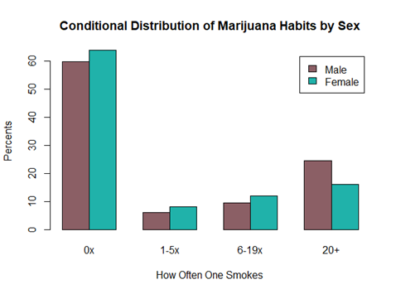

**Figure 2.** Conditional Distribution of Marijuana Usage by Sex with Percentages. Table of data in Appendix B.

The bar plot in Figure 2 exemplifies the distribution of marijuana habits using percentages within the levels of sex. There are about 2% more females smoke between 1-19 times than males; however, when looking at 20+ times of smoking, 8% more males answered yes than females. Therefore, we are able to reject the null hypothesis and accept the alternative hypothesis that sex does have a relationship with marijuana usage. Specifically, males are more likely to use and abuse marijuana than females.

***Relationship Between Parental Presence and Marijuana Usage:***

The next topic to be discussed is the possible association between marijuana usage, parental presence, and sex. It was hypothesized that those respondents who are male and live only with their mother and females who live only with their mother are less likely to smoke marijuana than males and females who either live with both or live with neither parent. This research is using the combined marijuana categories that were used in the exploration of the relationship between sex and marijuana usage and four levels of parental presence: father, meaning one lived with this parent only, mother, meaning one lived with this parent only, and neither, meaning there was no parental presence in their household, and both, meaning they lived with both parents. Through significant findings (x2=100, df=20, p-value<2e-16) the null hypothesis can be rejected. Although males who live with their fathers are more likely to smoke marijuana than males who live with their mother, males who live with both parents are the least likely to smoke marijuana and those who live with neither parent present are the most likely to use at any level. In addition, the null hypothesis as well as the specific hypothesis conceived, was not supported for the female data set either through similar significant data (x2=200, df=20, p-value<2e-16). It was found that females who live with their father are more likely to smoke than females who live with their mothers. Although, the females’ data set is similar to the male’s data set thus those who live with both a mother and father are the least likely to use marijuana and those who live with neither parent are the most likely.

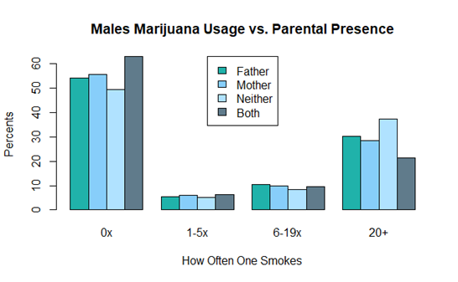

**Figure 3.** Conditional Distribution of Males Marijuana Usage by Parental Presence Using Percentages. Table of data in Appendix B.

The above figure shows the relationship that is between the male high schooler’s marijuana usage and their parental presence at home. Each distribution of parental options in the 0 times category has a range of about 13% and clearly those who have both a mother and father at home make up the highest percentage of those who have never tried marijuana before. There are 1% more males in this category belonging to those who only live with their mother. Moreover, throughout the rest of the data set those who live with their mother are less likely to smoke marijuana than those who live with their father. In the level of smoking 1-5 times there is a range of 1% and the range for the next level up is only 2%. In the next category there is a larger range of 16%, and the males who live with their mother clearly smoke less in this category than those who live with their father; this trend reflects the data collected in the first level of smoking 0 times. Thus, the hypothesis that was conceived is not entirely wrong; however, those who live with both a mother and father presence in their house are the least likely to smoke at any level.

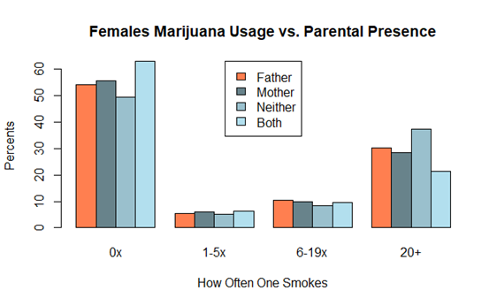

**Figure 4.** Conditional Distribution of Females Marijuana Usage by Parental Presence Using Percentages. Table of data in Appendix B.

The above figure illustrates the relationship between the two variables of marijuana usage and parental presence all looked through a lens that is the variable of sex. To begin, in the 0 times category of smoking, the combination of each distribution of parental presence has a range of 22%, the highest belonging to those who live with both their parents with females who live with their mother as a runner up. In the next level of marijuana usage there is a range of about 1%; within each distribution only about 8% of females smoke. In the next level there are more females and the range is about 4%, however the percentage of females who smoke who live with their father and those who live with their mother is almost the same. In the next category of marijuana usage, it becomes more apparent that those who live with their father are more likely to smoke than those who live with their mothers. Although, in all cases, females, similar to males, who live with both parents are the least likely to smoke marijuana and those with neither parent figure in their house have the highest percentage.

***Marijuana Usage Over Time:***

Next, the marijuana usage of high schoolers was explored over the decade from 2006 to 2016. The levels of marijuana usage have been condensed into three categories of None, Moderate, and Abuse. In the none category is the respondents who answered they smoked marijuana zero times, moderate includes those who reported using marijuana between 1 and 19 times, and in the abuse category is those who use marijuana 20 plus times. Our alternative hypothesis for this question is that over time, high schoolers have increased their moderate use and abuse of the drug marijuana and the percentages of people who have never used marijuana will decrease over this same time interval. This hypothesis is supported through the figures below that as the years have passed more people have tried marijuana and an increasing number of high schoolers are being included in the percentages that represent the moderate use and abuse of marijuana categories. Although, there is a difference between the sexes that was not hypothesized about: males are more likely than females to abuse marijuana/fall into the category of smoking more than 20 times.

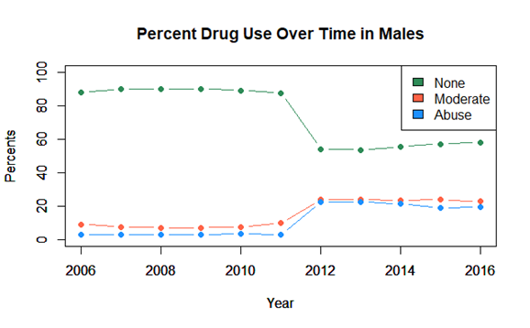

**Figure 5.** Time Series of Percent Drug Use Over Ten Years in Males.

The above figure is a time series of the data from the most recent decade that exemplifies the marijuana usage of male high school seniors. The time series begins in 2006 where 88% of males had never smoked marijuana; this number continues to grow where is peaks in 2009 at 90.11% of males although this number does not make a significant decrease until 2012 where the respondents that fall in this category is only 58% of males. Moreover, the moderate use and abuse of marijuana in males in 2006 was around 50% less males through 2008 and 2011. Then, in 2012 the moderate use and abuse in males increases to about 22% of males, which reflects the drastic change in marijuana usage with those who had never tried marijuana before. It was during this time in which states were beginning to change their legislature concerning the recreational use of marijuana. Specifically, in 2012 Washington and Colorado legalized the recreational use of marijuana. (Trumble and Kasai 2017). This started a chain reaction with several other states that includes decriminalization and the legalization of marijuana and as of right now there are 10 states with recreational use legalized and 23 states that have medicinal use legalized (Governing States 2018). Furthermore, the percentages do not change much after 2012 just small adjustments over the years and the difference between the percentage of those who have never tried marijuana and those who use it a moderate amount is growing smaller and in 2016 is 35%. In addition, there is an even bigger difference of 39% between those who never use and those who abuse marijuana.

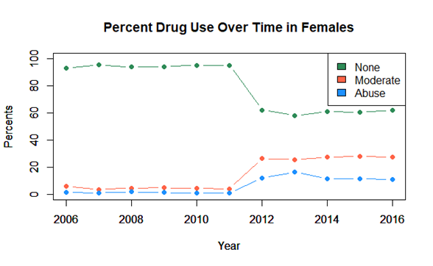

**Figure 6.** Time Series of Percent Drug Use Over Ten Years in Females.

This figure is a time series recording the trend of how often female high schoolers smoke over the past decade. This series starts in 2006 where 93% of females reported never having smoked marijuana which slowly increases to its peak of 95% of females in 2011. The next year, in 2012 there is a large decrease of 32% of females who have never tried marijuana before. Simultaneously there is an increase in moderate use by 18% and an increase in abuse of 10% of high schoolers. This increase is also most likely due to the legislature concerning the legality of recreational use of the drug marijuana; new legislature was passed in this year and is continuing to be passed in order to legalize marijuana which could lead to this trend of an increase in high schoolers using marijuana. Different than the male counterparts of this study, the females did not pass 20% abusing marijuana. There is an average difference between percentage of males that are in the category of abusing marijuana and females who do of about 10%. Thus, supporting the hypothesis that overtime there will be an increase in marijuana usage, and supporting the hypothesis from a different section of analysis, males are more likely to smoke than females.

**Conclusion:**

When considering the data gathered on high school students and their marijuana usage, sex, and parental involvement in the home, we have noticed a variety of associations and differences that lie among the variables. Based on the overall responses from MTF, we have highlighted that 39.32% of high schoolers have smoked or used marijuana. Comparing the conditional distribution of marijuana usage by sex, it is apparent that majority of smokers tend to be male. In this case, for our first research question, we accept that there is an association between smoking and sex. This conclusion has been reinforced by other studies such as the one conducted by Crane, Langenecker, and Mermelstein.

Looking at the results of the chi-squared tests between marijuana usage and parental presence in the home, the question of whether parental presence and marijuana usage are associated with each other is supported. Our hypotheses were incorrect in the way we presumed the variables to be associated based on breaking the data up between sexes. The main revelation that the graphs showed, was that respondents with both parents in the home were the least likely to smoke marijuana, and respondents with neither parent in the home were the most likely to smoke marijuana.  Therefore, the association and the distribution are similar for both sexes and their conditional distributions. Both p-values were well below 0.5, at about 2e-16 verifying the significance of the results. Also, both bar graph displays showed majority of respondents at 0 times with both parents present. Considering the social control theory, that having positive social relationships reduces the risk of participating in antisocial behaviors, parental presence influences an adolescent’s choice on refraining from marijuana usage. “When [adolescents] are not close to their parents, however, they do not feel as constrained to conform to the desires of their parents, and they are more likely to experiment with drugs” (Bahr S.J., Dorius C.J., Hoffmann J.P., & Lovelady E.H., (2004). The results obtained, emphasize that parental presence influences the decision adolescents make to smoke marijuana or not.

As the years change, so does the data on marijuana usage. With the data sets gathered and displayed in the time graphs from 2006 to 2016, we accept our hypothesis that the moderate to abusive usage of marijuana has increased throughout time. As mentioned previously, there are a variety of factors that could be of association to this increase, such as the recreational legalization of marijuana in a variety of states. In combination with the results of parental presence in the home, we can make connections about family dynamics, societal changes, and marijuana usage. As Kazuo Yamaguchi and Denise B. Kandel discussed in their 1985 article on marijuana and families, marijuana usage or non-usage can be a decision made because of social roles defined in adolescent and/or adult years. There is no direct correlation between the variables analyzed in this report, but from the results one can say that marijuana usage has a relationship with sex, family roles, and societal changes through time.

**Appendix A:**

These are the questions on the survey that were investigated in this report that MTF project gave to high school seniors.

Question 1: What is your sex?

Possible answers: male, female

Question 2: On how many occasions (if any) have you used marijuana (grass, pot) or hashish (hash, hash oil) in your lifetime?

Possible answers: 0 occasions, 1-2 times, 3-5 times, 6-9 times, 10-19 times, 20-39 times, 40 or more times

Question 3: Which of the following people live in the same household with you? Father (or male guardian)

Possible answers: marked (yes), unmarked (no)

Question 4: Which of the following people live in the same household with you? Mother (or female guardian)  
Possible answers: marked (yes), unmarked (no)

**Appendix B:**

***Appendix B Table of Contents***

Table 1. Marijuana Habits with Combined Levels……………………………………………...19

Table 2. Conditional Distribution of Marijuana Habits by Sex………………………………….19

Table 3. Conditional Distribution of Marijuana Usage of Males by Parental Presence…………19

Table 4. Conditional Distribution of Marijuana Usage of Females by Parental Presence………20

|  |  |  |  |
| --- | --- | --- | --- |
| High Schoolers Marijuana Habits with Combined Categories Percentages | | | |
| 0x | 1-5x | 6-19x | 20x |
| 61.68 | 7.10 | 10.57 | 20.79 |

**Table 1.** How Often One Smokes with Both Sexes Using Percentages with Combined Levels.

|  |  |  |  |  |
| --- | --- | --- | --- | --- |
| Sex | How Often One Smokes | | | |
| 0x | 1-5x | 6-19x | 20+ |
| Male | 59.897 | 6.154 | 9.490 | 24.459 |
| Female | 63.869 | 8.110 | 11.963 | 16.058 |

**Table 2.** Conditional Distribution of Marijuana Habits by Sex Using Percentages.

|  |  |  |  |  |
| --- | --- | --- | --- | --- |
| Parent Present | How Often One Smokes | | | |
| 0x | 1-5x | 6-19x | 20+ |
| Father | 54.03 | 5.37 | 10.40 | 30.20 |
| Mother | 55.68 | 5.92 | 9.97 | 28.43 |
| Neither | 49.31 | 5.17 | 8.28 | 37.24 |
| Both | 62.91 | 6.40 | 9.45 | 21.24 |

**Table 3.** Conditional Distribution of Males Marijuana Usage by Parental Presence Using Percentages.

|  |  |  |  |  |
| --- | --- | --- | --- | --- |
| Parent Present | How Often One Smokes | | | |
| 0x | 1-5x | 6-19x | 20+ |
| Father | 51.58 | 8.60 | 14.03 | 25.79 |
| Mother | 58.96 | 8.88 | 14.91 | 17.25 |
| Neither | 46.67 | 8.63 | 11.76 | 32.94 |
| Both | 68.02 | 7.75 | 10.86 | 13.37 |

**Table 4.** Conditional Distribution of Females Marijuana Usage by Parental Presence Using Percentages.

**References**

Bahr S.J., Dorius C.J., Hoffmann J.P., & Lovelady E.H. (2004). Parenting Practices as Moderators of the Relationship Between Peers and Adolescent Marijuana Use. *Journal of Marriage and Family, 66.* 163-178.

Crane N.A., Langenecker S., & Mermelstein R.J., (2015). Gender differences in the associations among marijuana use, cigarette use, and symptoms of depression during adolescence and young adulthood. *Elsevier Addictive Behaviors 49,* 33-39.

Governing Magazine. “State Marijuana Laws in 2018 Map.” *Governing Magazine: State and Local Government News for America's Leaders*, Governing, 7 Nov. 2018, www. governing.com/gov-data/safety-justice/state-marijuana-laws-map-medical-recreational.html.

Kandel D.B., Yamaguchi K. (1985). On the Resolution of Role Incompatibility: A Life Event History Analysis of Family Roles and Marijuana Use. *American Journal of Sociology, 90.* 1284-1325.

Trumble, Sarah, and Nathan Kasai. “America's Marijuana Evolution – Third Way.” *America’s Marijuana Evolution*, 24 Aug. 2017, www.thirdway.org/report/americas-marijuana- evolution.